
A 10
SET NO : 2

Sreenidhi Institute of Science & Technology
(An Autonomous Institution)
Code No: 111ME02

B. TECH. I – Year II – Semester Examinations, June/July, 2012 (Regular-AN)
ENGINEERING DRAWING - II ( ECM & ME )

Time: 3 Hours Max. Marks : 70

Note : No additional answer sheets will be provided.

Part-A (Objective Type)
Max.Marks:20

Answer all QUESTIONS.
1. Write the limitations of isometric projection.
2. Explain the applications of perspective view with an example.
3. Define visual ray method.
4. Why second angle projection and third angle projections are not preferred in drawing?
5. List some of the CAD packages used for modeling and drafting.
6. What is the RF of a scale which measures 2.5 inches to a mile?
7. Differentiate between the diagonal scale and vernier scale.
8. What is meant by development of surfaces? What is its purpose?
9. Write the applications of development of surfaces in engineering.
10. Define isometric axis.
Part – B
Max. Marks: 50

ANSWER ANY FIVE QUESTIONS. EACH QUESTION CARRIES 10 MARKS.

1. Draw the front view, top view and side view of the object whose isometric view is shown in figure 1. [ 10 M ]
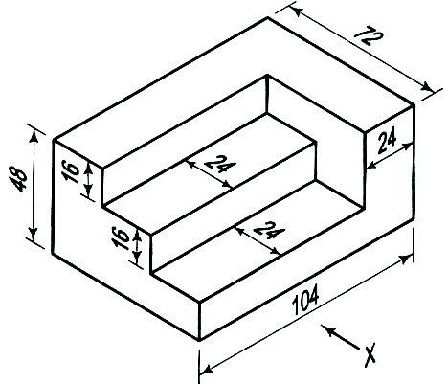

2. Draw the isometric view for the orthographic views shown in figure 2. [ 10 M ]
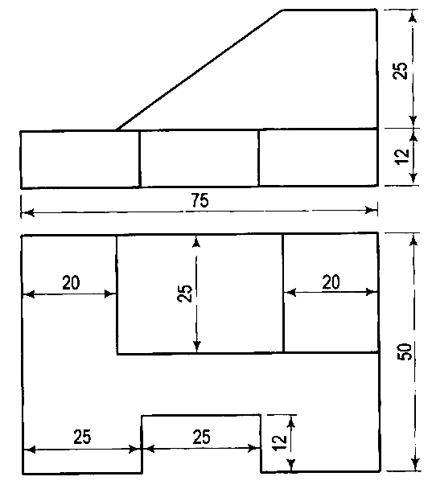

3. A hexagonal plane of 30 mm side lies on the ground plane. One of its corners is touching the picture plane and an edge is perpendicular to the PP. The station point is 30 mm in front of PP and 60 mm above GP and lies in a central plane which is located at a distance of 90 mm to the resting corner. Draw the perspective view of the hexagonal plane. [ 10 M ]

4. Write the advantages of CAD system in design and discuss in brief about various input devices used in computers. [ 10 M ]

5. Construct a vernier scale of RF = 1/25 to read centimeters up to 4 meters and mark a length representing 2.39 m on it. [ 10 M ]

6. A hexagonal pyramid side of base 30 mm axis 70 mm is resting on HP on its base it is cut by a section plane perpendicular to VP and inclined at 45° to HP and passing through the midpoint of the axis of the pyramid. Draw the development of the lateral surface of the truncated pyramid. [ 10 M ]

7. A cone of base diameter 60 mm and axis length 70 mm rests with its base on HP. It is cut by a plane perpendicular to both the HP and VP at a distance 15 mm to the left of the axis. Draw the development of the lateral surface of the remaining portion. [ 10 M ]

8. A square pyramid of side 30 mm, axis length 50 mm is centrally placed on the top of the cube of side 50 mm. Draw the isometric view of the combined solid.
[ 10 M ]
-- 00 -- 00 --

